Abstract：
该报告是关于Kaggle中的一个关于珊瑚礁水下视频中训练的物体检测模型，实时准确地识别海星的竞赛的目标。实验的中的目标是威胁澳大利亚大堡礁的物种，名为食珊瑚的棘冠海星（简称COTS）。实验将使用yolov5模型对数据集中的海星进行识别。Kaggle：https://www.kaggle.com/competitions/tensorflow-great-barrier-reef/overview

This report discusses a Kaggle project that aims to recognise starfish in real time using an object detection model that was trained on underwater coral reef videos. The experiment was focused on the coral-eating crown-of-thorns starfish (COTS), a species that poses a threat to Australia's Great Barrier Reef. The yolov5 model will be used in the experiment to find starfish in the data set.This report discusses a Kaggle project that aims to recognise starfish in real time using an object detection model that was trained on underwater coral reef videos. The experiment was focused on the coral-eating crown-of-thorns starfish (COTS), a species that poses a threat to Australia's Great Barrier Reef. The yolov5 model will be used in the experiment to find starfish in the data set.
Kaggle：https://www.kaggle.com/competitions/tensorflow-great-barrier-reef/overview

- Data analysis
数据的训练集的数据是从视频中截取的图片特征。训练集共有23491个图片类特征。这写图片来自于三个不同的视频。如下图（\ref{video_id} video_0的样本相对于video_1和video_2少了接近1000多个样本。
The visual feature that was extracted from the video makes up the data of the training set of data. There are 23491 total picture-like features in the training set. Three distinct videos were used to create these images. As seen in the following figure (\ref{video_id}), Compared to videos 1 and 2, video 0 has samples that are almost 1000 samples less.
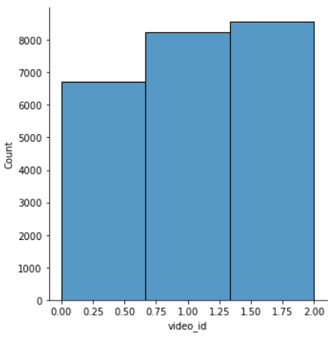
在数据集中存在了已经认为标记了检测框的图片，同时也存在没有被标注检测框的图片。根据下图{\ref{Boxing exists}},可以看出没有检测框的数据的数量是有检测框的数据的数量的四倍。
photographs that have been deemed to be marked with a detection frame and photographs that have not been marked with a detection frame can both be found in the data set. The number of data without detection boxes is four times that of data with detection boxes, as seen in the accompanying figure, \ref{Boxing exists}.
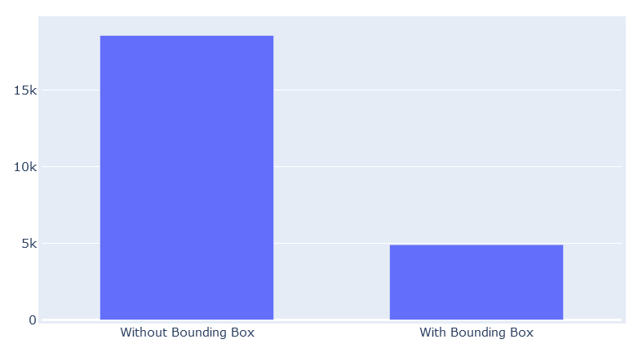

接下来，确认这些有检测框的图片中都拥有多少个检测框，因为在某些图片中，并不值存在一个需要被检测的目标，由于是视频中的图片，所以有些图片会出现更多的目标。(\ref{How many no boxes})，可以看出图片中拥有一个检测框的图片数量最多，当超过五个时，数据量非常少。
Next, confirm how many detection frames there are in these pictures with detection frames, because in some pictures, there is not a target to be detected. Since it is a picture in the video, some pictures will appear more The goal. (\ref{How many no boxes}), it can be seen that the number of pictures with one detection box in the picture is the largest, and when there are more than five, the amount of data is very small.
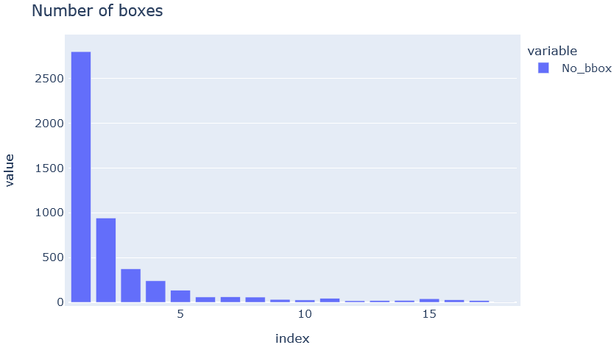
数据集同时提供了一个csv文件，在这其中有5个columns，分别是video_id,video_frame,sequence,annotations。其中video_frame 作为视频中图像的帧数以及sequences，sequence_frame是序列ID，并没有什么作用。annotations是任何海星探测的边界框，其格式为可以直接用Python计算的字符串。这个对于模型是能提供重要信息的特征。
The data set also provides a csv file, in which there are 5 columns, namely video_id, video_frame, sequence, annotations. Among them, video_frame is the frame number and sequences of the image in the video, and sequence_frame is the sequence ID, which has no effect. annotations are the bounding boxes of any starfish detections, formatted as strings that can be computed directly in Python. This is an important informative feature for the model.

- Related Method
YOLOv5是一种基于深度学习的目标检测算法，是YOLO (You Only Look Once) 系列算法由Joseph Redmon和Alexey Bochkovskiy等人开发.它使用现代深度学习框架PyTorch实现，能够快速且准确地检测出图像中的目标，并且可以在较小的计算资源下进行实时检测。

YOLOv5 is a deep learning-based target detection algorithm. It is a YOLO (You Only Look Once) series of algorithms developed by Joseph Redmon and Alexey Bochkovskiy. It is implemented using the modern deep learning framework PyTorch, which can quickly and accurately detect objects in images. target, and can be detected in real time with relatively small computing resources.

Yolov5的模型的结构主要分为输入端，backbone，head。模型的结构图如下图所示。\ref{yolo strcture}
The structure of the Yolov5 model is mainly divided into input, backbone, and head. The structure diagram of the model is shown in the figure below. \ref{yolo structure}
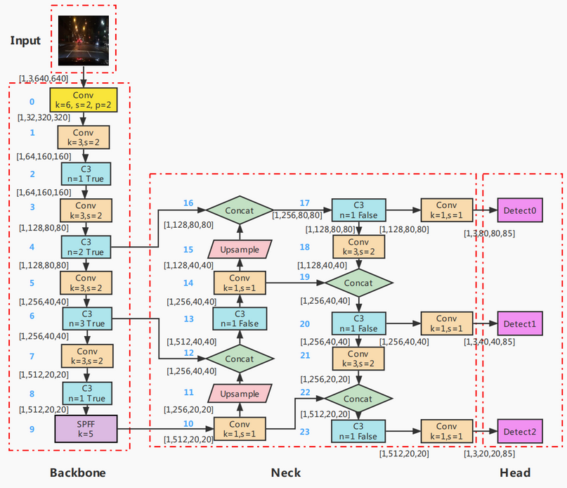

Yolov5使用的backbone结构是CSP（cross-stage partial）Darknet53，它是对传统Darknet53的改进，通过使用cross-stage部分连接来提高网络的效率和准确性。Darknet53是一个卷积神经网络模型，他的特点是通过堆叠多个卷积和残差链接层来提高特征提取的效果。CSP Darknet53将输入特征图分成两个部分，一部分通过一系列卷积和残差块进行处理，另一部分直接进行一些简单的处理，然后将两部分的结果通过concatenation操作合并在一起。这种结构既减少了参数数量，又保持了网络的有效性和准确性。此外，CSP Darknet53还使用了一些技巧来进一步提高网络的性能，使用SPPF（Spatial Pyramid Pooling Fast）模块来处理不同大小的感受野，SPPF由SPP改进而来，SPP先通过一个标准卷积模块将输入通道减半，然后分别做kernel-size为5，9，13的max pooling（对于不同的核大小，padding是自适应的）。对三次最大池化的结果与未进行池化操作的数据进行concat，最终合并后channel数是原来的2倍。yolo借鉴了空间金字塔的思想，通过SPP模块实现了局部特征和全部特征，丰富了图片的信息程度，有利于待检测图像中目标大小差异较大的情况，对yolo这种复杂的多目标检测的精度有很大的提升。由于Darknet53的优势在于学习图像特征，并可以高效的解决大量类别的物体分类问题。这也是为什么在这个数据集中，使用yolov5的原因，根据描述，在图片中有可能存在几百中不同类别的生物和植物，而开发人员需要从多个类别中选出唯一需要被识别的海星。

Yolov5 uses CSP (cross-stage partial) Darknet53 as its backbone structure. This variant of Darknet53 enhances the network's accuracy and efficiency by utilising cross-stage partial connections. In order to enhance the effectiveness of feature extraction, the convolutional neural network model Darknet53 is characterised by stacking numerous convolutional and residual link layers. The input feature map is split in half by CSP Darknet53, with one half going through a number of convolution and residual blocks and the other half going straight through some basic processing. The two halves' results are then concatenated using the concatenation operation. This layout keeps the network's efficiency and precision while simultaneously reducing the number of parameters. Additionally, CSP Darknet53 employs a number of approaches to enhance network speed, utilising the SPPF (Spatial Pyramid Pooling Fast) module to handle various receptive field sizes. SPP has been replaced by SPPF. SPP initially inputs data using a common convolution module. The channel is divided in half, and max pooling is then carried out with kernel sizes of 5, 9, and 13 (the padding is adaptive for different kernel sizes). When the three maximum pooling processes' results are combined with the data that hasn't been pooled, the number of channels following the final merging is double what it was initially. When the three maximum pooling processes' results are combined with the data that hasn't been pooled, the number of channels following the final merging is double what it was initially. Yolo, which is based on the spatial pyramid theory, utilises the SPP module to realise local features as well as all characteristics, enhancing the picture's information level, and is advantageous in situations when there is a significant target size difference in the image to be detected. Accuracy has significantly increased for complicated multi-target detection systems like Yolo. Darknet53 has the advantage of learning picture features, which allows it to effectively address a wide range of object categorization issues. Yolov5 is utilised in this data collection as a result. The description claims that there may be hundreds of various kinds of animals and plants in the image, and developers must choose the one starfish from among many distinct kinds that needs to be recognised.

在Neck部分中PANet在FPN（feature pyramid network）上提取网络内特征层次结构，FPN中顶部信息流需要通过骨干网络(Backbone)逐层地往下传递，这也是为了更好的提取特征。\cite{b1}由于层数相对较多，因此计算量比较大。
In the Neck part, PANet extracts the feature hierarchy in the network on the FPN (feature pyramid network). The top information flow in the FPN needs to be passed down layer by layer through the backbone network (Backbone), which is also for better feature extraction. \cite{b1} has a relatively large amount of calculation due to the relatively large number of layers.

PANet在FPN的基础上又引入了一个自底向上(Bottom-up)的路径,如图\ref{PANet strcture}。经过自顶向下(Top-down)的特征融合后，再进行自底向上(Bottom-up)的特征融合，这样底层的位置信息也能够传递到深层，从而增强多个尺度上的定位能力\cite{b2}。
PANet introduces a bottom-up (Bottom-up) path on the basis of FPN, as shown in \ref{PANet structure}. After top-down (Top-down) feature fusion, then bottom-up (Bottom-up) feature fusion, so that the underlying position information can also be transmitted to the deep layer, thereby enhancing the positioning ability on multiple scales\ cite{b2}.
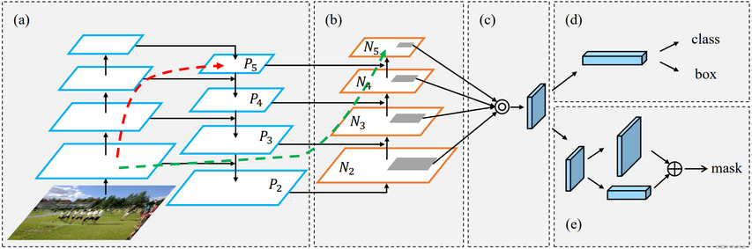
\cite{b2} (a) FPN backbone, (b) bottom-up path augmentation, (c) adaptive feature pooling

Head层这重要用于检测目标，Head中的3个检测层分别对应Neck中得到的3种不同尺寸的特征图。特征图上的每个网格都预设了3个不同宽高比的anchor，可以在特征图的通道维度上保存所有基于anchor先验框的位置信息和分类信息，用来预测和回归目标。
Target detection is done mostly using the head layer. The three detection layers in the Head match the three different-sized feature maps obtained in the Neck. Each grid on the feature map is pre-set with three anchors of varying aspect ratios that may be used to anticipate and retrieve the target by saving all positional and classificational data based on the anchor preceding frame in the feature map's channel dimension.

Yolov5的检测思想可以分为三步：

- resize image
- Run conv network
- Non-max suppression
首先yolo将特征图划分为SXS的grid cells每个格子负责对落入其中的目标检测，一次性的预测目标的便捷框，置信度，类别概率。将分格的图片分别输出为bounding boxes和置信度（图片中有n个物体框），另一个是class probability map结合后得到最后结果 \ref{probability}。物体框引入了Anchor机制，这是一种先验验机制，预先设定若干大小的Anchor，这也对应了上文框架中的三种不同尺寸的特征图。最后的评测将会采用类别置信度得分，它测量分类和定位的置信度。\cite{b2}条件类别概率是检测目标在给出一个目标是存在时属于某个类别的概率。定位的置信度也叫IOU（intersection over union）这是正事物体检测框和预测的检测框重叠的比例。两者一起的乘积为最后的置信度。

The detection idea of Yolov5 can be divided into three steps:
1.resize image
2.Run conv network
3.Non-max suppression
First, yolo divides the feature map into grid cells of SXS. Each grid is responsible for detecting the target falling into it, and one-time prediction of the target's convenient box, confidence, and category probability. Output the divided pictures as bounding boxes and confidence (there are n object boxes in the picture), and the other is the class probability map to get the final result \ref{probability}. The object frame introduces the Anchor mechanism, which is a priori mechanism that presets several sizes of Anchor, which also corresponds to the feature maps of three different sizes in the above framework. The final evaluation will use the category confidence score, which measures the confidence of classification and localization. \cite{b2}Conditional class probability is the probability that a detected object belongs to a certain class given that an object is present. The confidence of positioning is also called IOU (intersection over union), which is the ratio of the overlap between the detection frame of the real object and the predicted detection frame. The product of the two is the final confidence.
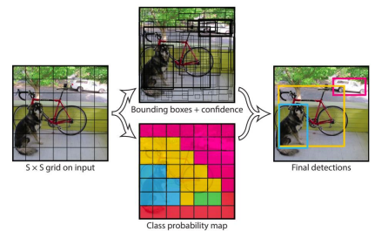

Zhu, X., Lyu, S., Wang, X., & Zhao, Q. (2021). TPH-YOLOv5: Improved YOLOv5 based on transformer prediction head for object detection on drone-captured scenarios. In Proceedings of the IEEE/CVF international conference on computer vision (pp. 2778-2788).

Thuan, D. (2021). Evolution of Yolo algorithm and Yolov5: The State-of-the-Art object detention algorithm.

Iou:intersection over union 检测框重叠的比例，
真实物体检测框，和预测物体的检测框
Iou = Area of overlap/area of union

Iou可以设定阈值来分类 TP FP FN TN

AP average precison 平均精度 precision-recall curve 下方的区域

Yolo 将特征图划分SXS
- resize image
- Run conv network
- Non-max suppression

基本思想
将分格的图片分贝输出为bounding boxes和置信度（图片中有n个物体框），另一个是class probability map结合后得到最后结果。

多尺度融合：因为在划分网格时，图片中的网格有大有小，这会导致得出的置信度不同。
Feature pyramid network

Anchor 锚框

Yolov5检测框的生成是

